

**Final year project management system - documentation**

Contents

Chapter 1 Introduction: 3

About the Project: 3

Group Members: 3

Haj Wali (SP23-BSE-064) 3

Zohaib Ahmed (SP23-BSE-044) 3

Mirza Saad (SP23-BSE-036) 3

Okasha Arif (SP23-BSE-057) 3

Chapter 2: Use Case Diagram: 3

Chapter 3 Fully Dressed Use Cases: 4

Haj Wali (SP23-BSE-064) 4

User Authentication 4

Role-based Dashboard 5

Zohaib Ahmed (SP23-BSE-044) 5

Proposal Submission 5

Status Tracking 7

Mirza Saad (SP23-BSE-036) 7

File Upload Module 7

Submission Handling 8

Okasha Arif (SP23-BSE-057) 8

Supervisor Review 8

Feedback System 8

Chapter 4 SSDs: 8

Haj Wali (SP23-BSE-064) 8

Zohaib Ahmed (SP23-BSE-044) 9

Mirza Saad (SP23-BSE-036) 10

Okasha Arif (SP23-BSE-057) 10

Chapter 5: communication diagram: 10

Haj Wali (SP23-BSE-064) 10

Zohaib Ahmed (SP23-BSE-044) 11

Mirza Saad (SP23-BSE-036) 11

Okasha Arif (SP23-BSE-057) 12

Chapter 5: class diagram: 13

Haj Wali (SP23-BSE-064) 13

Zohaib Ahmed (SP23-BSE-044) 13

14

Mirza Saad (SP23-BSE-036) 14

Okasha Arif (SP23-BSE-057) 15

# Chapter 1 Introduction:

## About the Project:

A full-stack web application designed to manage Final Year Projects for universities, enabling smooth collaboration between students, supervisors, and admins. It simplifies proposal submission, feedback exchange, file uploads, and grading in one centralized system.

## Group Members:

### Haj Wali (SP23-BSE-064)

### Zohaib Ahmed (SP23-BSE-044)

### Mirza Saad (SP23-BSE-036)

### Okasha Arif (SP23-BSE-057)

# Chapter 2: Use Case Diagram:

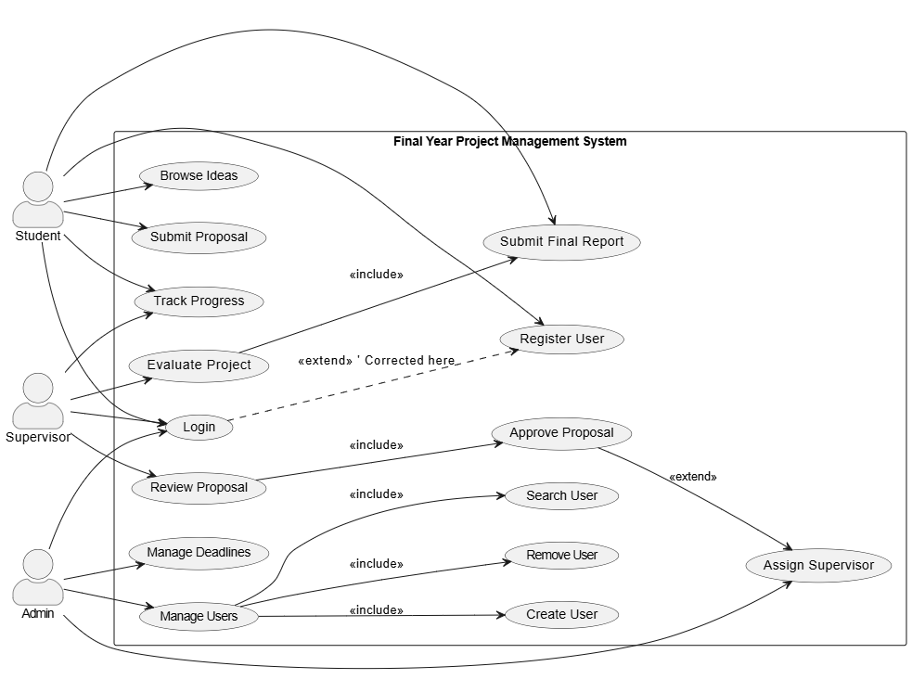

# Chapter 3 Fully Dressed Use Cases:

### Haj Wali (SP23-BSE-064)

### User Authentication

| **Attribute** | **Details** |
| --- | --- |
| **Use Case Name** | User Authentication |
| **Primary Actor** | Student (or any user needing to log in to the system) |
| **Goal in Context** | The student logs in to the FYP Management System to access their dashboard and other personalized features. |
| **Stakeholders and Interests** | - **Student**: Wants secure access to the system. - **System**: Needs to authenticate the student and grant access to authorized resources. |
| **Preconditions** | - The user has a registered account with email and password. - The student has internet access. |
| **Postconditions** | - **Success**: The student is authenticated and redirected to their dashboard. - **Failure**: An error message is shown. |
| **Main Success Scenario** | 1. The student accesses the login page. 2. The student enters their email and password. 3. The system validates the credentials. 4. If valid, the student is logged in and redirected to the dashboard. |
| **Extensions (Alternative Flows)** | **Extension 1 – Invalid Credentials**: - Error message shown. - Student can try again or reset password. **Extension 2 – Account Locked**: - After several failed attempts, the account is temporarily locked. - Student can unlock account via email. **Extension 3 – Session Expiry**: - After inactivity, the student is logged out. - Student needs to log in again. |
| **Description** | The use case describes the secure login process for students to access the system and related features. |
| **Special Requirements** | - Login page should be responsive. - Authentication should occur within 2 seconds. - HTTPS must be used for secure credential transmission. - Implement measures to prevent brute force attacks. |
| **Assumptions** | - The student has internet connectivity. - The student has already registered and verified their account. |
| **Frequency of Use** | Every time the student wants to access the system (multiple times per day). |

Let me know if you’d like this in a downloadable file or converted into another format like a **Use Case Diagram**.

### Role-based Dashboard

### Zohaib Ahmed (SP23-BSE-044)

### Proposal Submission

| **Field** | **Details** |
| --- | --- |
| **Use Case ID** | UC-01 |
| **Use Case Name** | Submit Project Proposal |
| **Primary Actor** | Student |
| **Secondary Actor** | Supervisor |
| **Stakeholders and Interests** | - **Student**: Wants to submit a project proposal to initiate the final year project approval process.- **Supervisor**: Wants to review and approve or reject submitted proposals.- **Coordinator/Admin**: Wants to monitor all proposal submissions and supervisor feedback. |
| **Preconditions** | 1. Student must be logged into the FYP System.2. Student must be eligible (final year, approved by admin/coordinator).3. Supervisors are already assigned to students. |
| **Postconditions** | - **Success Guarantee**: Proposal is submitted, saved in the database, and forwarded to the assigned supervisor for review.- **Minimal Guarantee**: System provides proper error messages and retains form data if submission fails. |
| **Trigger** | Student selects the "Submit Proposal" option from their dashboard. |
| **Main Success Scenario (Basic Flow)** | 1. Student logs in and accesses the "Submit Proposal" module.2. System displays the proposal submission form.3. Student fills out the form.4. System validates input fields.5. Student submits the proposal.6. System saves proposal in the database.7. System assigns/notifies supervisor.8. Supervisor receives a notification.9. Confirmation message shown to student. |
| **Extensions (Alternate Flows)** | **3A. Invalid/Incomplete Proposal Form**- 3A1. System detects errors.- 3A2. Error messages shown.- 3A3. Student corrects and resubmits.**5A. Server/Database Error**- 5A1. Submission fails.- 5A2. "Submission failed" message displayed.- 5A3. Student retries later.**7A. Supervisor Not Assigned**- 7A1. System detects no assignment.- 7A2. Prompt: "Contact admin".- 7A3. Admin assigns manually. |
| **Special Requirements** | - Proposal file (if uploaded) must be PDF, max 10MB.- Form supports solo and group proposals.- Email notifications sent to student and supervisor.- All proposals must be time-stamped and logged. |
| **Business Rules** | - One proposal per group.- A student can’t be in more than one active group.- Supervisors can only review their assigned proposals. |

### Status Tracking

### Mirza Saad (SP23-BSE-036)

### File Upload Module

| **Section** | **Details** |
| --- | --- |
| **Use Case ID** | UC-01 |
| **Use Case Name** | Upload File |
| **Primary Actor** | Registered User (e.g., Admin or End-user) |
| **Stakeholders and Interests** | - **User**: Wants to upload files quickly and securely. - **System**: Ensures file integrity, format, and size compliance. - **Admin**: Wants control and logging of all uploaded files. |
| **Preconditions** | - User must be logged into the system. - User must have appropriate permissions to upload files. |
| **Postconditions** | - The file is stored on the server. - A reference to the file is saved in the database. |
| **Main Success Scenario** | 1. User navigates to the upload section. 2. User selects a file from their local device. 3. User clicks the 'Upload' button. 4. System validates the file format and size. 5. System stores the file on the server. 6. System stores file metadata (name, path, size, uploader, timestamp) in the database. 7. System confirms successful upload to the user. |
| **Extensions (Alternate Flows)** | **4a. File format or size is invalid:** - 1. System shows an error message. - 2. User selects a valid file and retries. **5a. Server storage fails:** - 1. System logs the error and notifies the user. - 2. Upload is aborted. |
| **Special Requirements** | - Maximum file size: 10MB. - Allowed file formats: PDF, DOCX, PNG, JPG. - Upload must complete within 30 seconds. - File scan for viruses before storing. |
| **Frequency of Use** | Frequently, depending on user role and module usage. |
| **Open Issues** | - Whether to support drag-and-drop uploads. - Whether to allow multiple file uploads in one session. |

### Submission Handling

### Okasha Arif (SP23-BSE-057)

### Supervisor Review

### Feedback System

# Chapter 4 SSDs:

### Haj Wali (SP23-BSE-064)

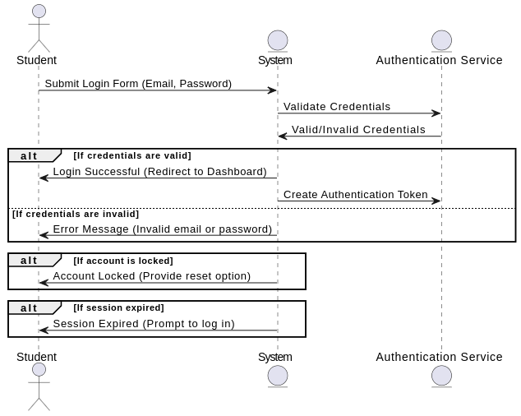

### Zohaib Ahmed (SP23-BSE-044)

### Mirza Saad (SP23-BSE-036)

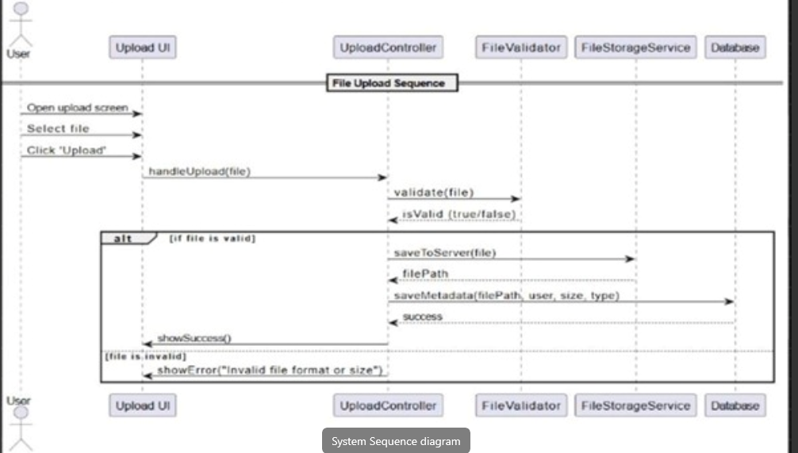

### Okasha Arif (SP23-BSE-057)

# Chapter 5: communication diagram:

### Haj Wali (SP23-BSE-064)

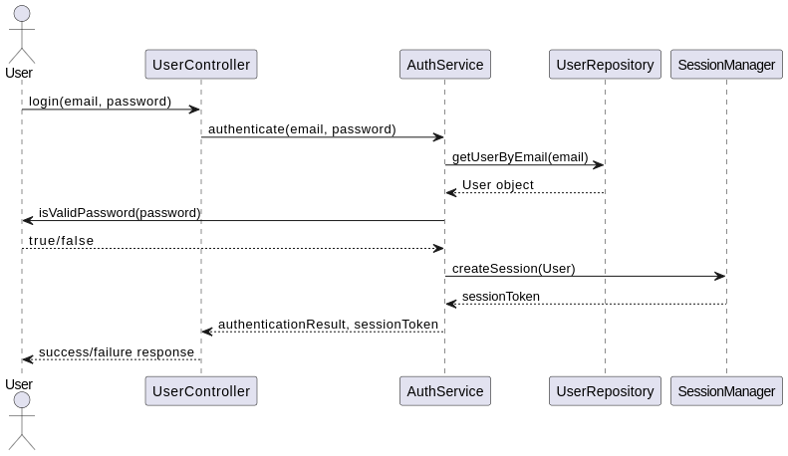

### Zohaib Ahmed (SP23-BSE-044)

### Mirza Saad (SP23-BSE-036)

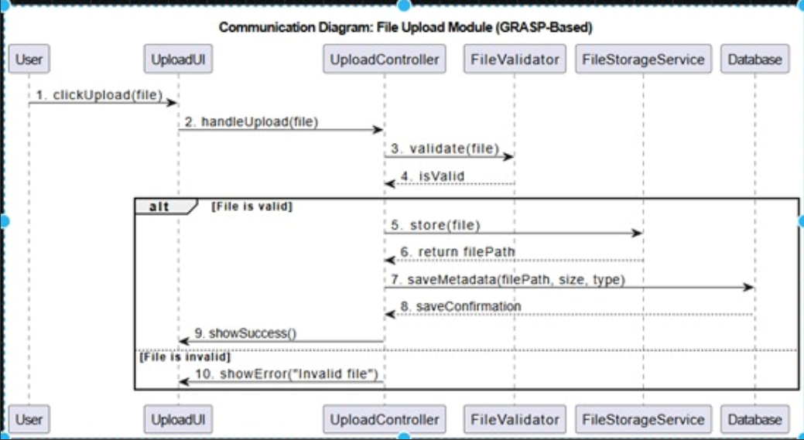

### Okasha Arif (SP23-BSE-057)

# Chapter 5: class diagram:

### Haj Wali (SP23-BSE-064)

### Zohaib Ahmed (SP23-BSE-044)

### 

### 

### Mirza Saad (SP23-BSE-036)

### Okasha Arif (SP23-BSE-057)